DANIEL M. PHILLIPS LEADERSHIP AWARD
WINNERS BY YEAR

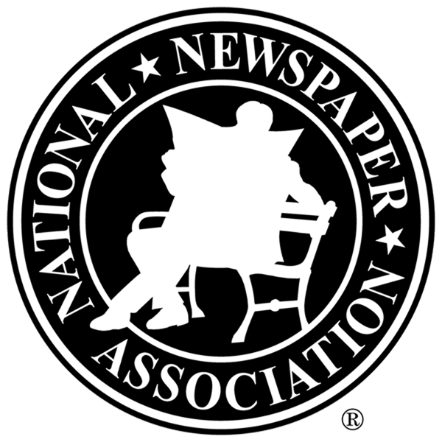

Name City, St Year

Jim Edgecombe Minden, NE 2008
Joel McNeece Bruce, MS 2009
Jeffrey W. Mayo Sallisaw, OK 2010
Gerri Peterson Mullen, NE 2011
No nominations received this year 2012
Eric NeSmith Athens, GA 2013
Derek Sawvell Wilton, IA 2014
Jeremy Waltner Freeman, SD 2015
Chris Rhoades Blair, NE 2016
Trevor Vernon Eldon, MO 2017

